# Keyman Keyboard Usage Instructions

Please make sure that Keyman is already running in your machine. This can be seen by the small keyboard key-like icon in the taskbar.



In some cases, the icon could be hidden as shown below.

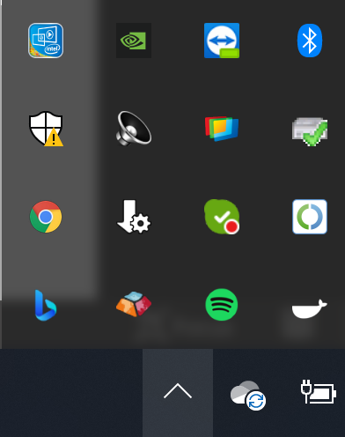

If you cannot see the icon, please start Keyman from the start menu.

With Keyman running, you should now be able to see the “Grantha Unicode Phonetic” and “Grantha Unicode Inscript” keyboards by clicking on the language icon (that most probably says ENG).

Now, click on the Keyman Icon and select configuration

Make sure that the Grantha keyboards are selected as shown below. If they’re not selected, please select them and then click OK.

For the phonetic keyboard, the keyboard mapping can be found under the start menu within the folder “Grantha Unicode Keyboard".

For Inscript, you can activate the onscreen keyboard

Using the language menu as shown above, set the Keyboard to “Grantha Unicode Phonetic” or “Grantha Unicode Inscript” . You can also invoke the language menu using windows key + space bar comination.

Open Microsoft Word (or any other word processing application) and set the font as “Noto Sans Grantha” or “Noto Serif Grantha”. (Sometimes the text may revert back to boxes, in such cases, please re-select the text and set the font as Noto Sans/Serif Grantha again)

You can now compose text in the Grantha script.

To ensure proper legibility and to avoid overcrowding of the text, please sufficiently increase the line-spacing.

*Overcrowded text*

*Text with sufficient line spacing*